Edit Your Own Version in One of Two Ways:
- Go to “File” > “Make a Copy” to Access in Google Docs
- Go to “File” > “Download As” > “Microsoft Word” to Download as a Word Doc

Click Here to Get Started With a Free Demo of
HubSpot’s Marketing and Blogging Software

How to Write a “What is” Blog Post

How often do you find yourself typing “what is [blank]” into Google? Weekly? Daily? Hourly?

Sometimes, your readers just need a quick answer to a question. Enter: the “what is” blog post. This is the opportunity for you to answer that question – and provide further details on the topic for the readers that want them (and, of course, to help your post rank better).

Writing these posts can also help your be chosen for Google’s featured snippet – the box that appears in Google search results with a few dozen words answering the question people search for. You can see an example of this below.

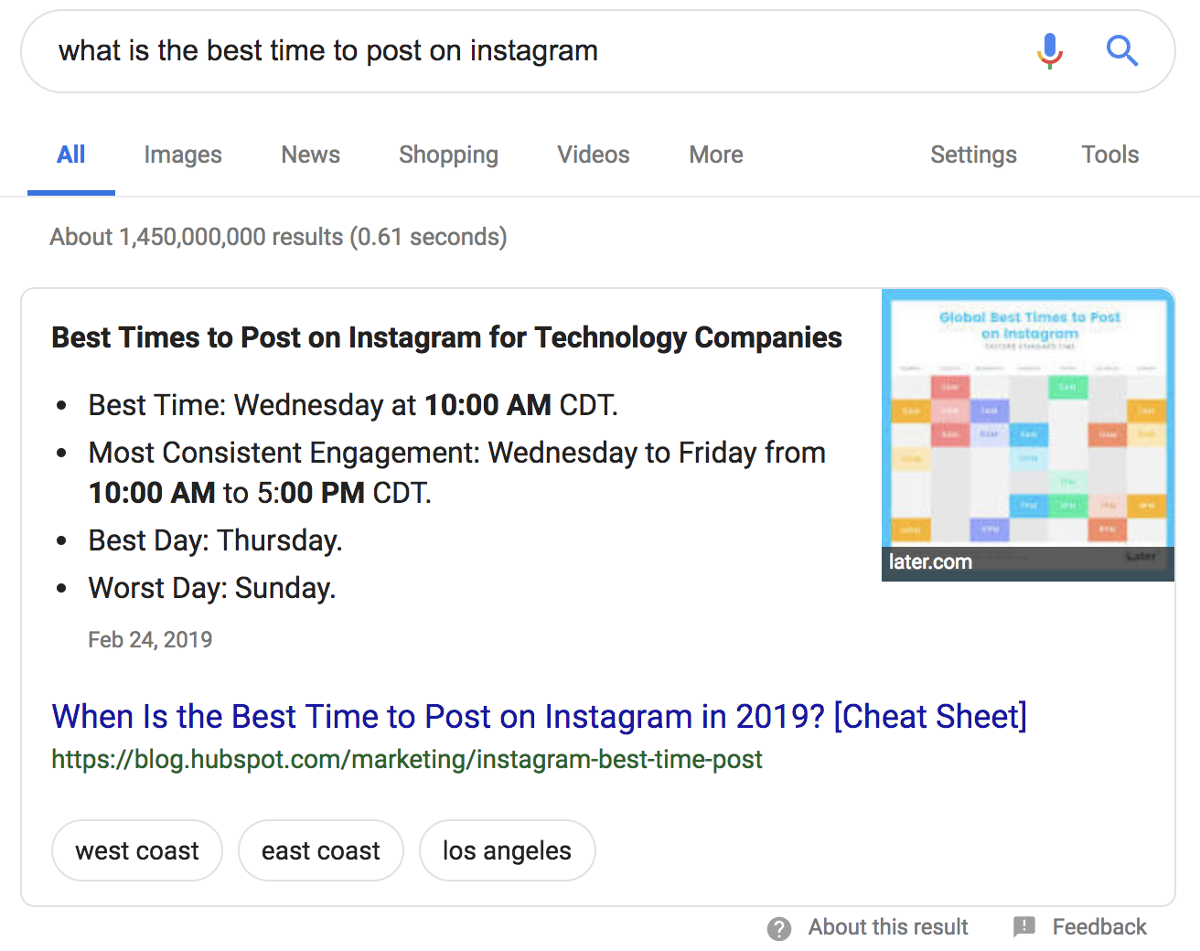

As you may be able to tell from the example above, the “what is” blog post can also take the form of a “when is,” “who is,” or “why is” blog. You can follow the same general guidelines for these posts as you would for a “what is” post.

“What is” blog posts are best for the following blog post ideas:
- Defining a term and/or a concept [i.e. “What is Marketing?”].
- Math and equation explanations [i.e. “What is First Call Resolution?”].

Outline: [Blog Post Title]
Keyword: [Enter Targeted Keyword]
Keyword MSV: [Enter Targeted Keyword’s Monthly Search Volume]
Author: [Enter Author Name]
Due Date: [Enter Due Date]
Publish Date: [Enter Desired Publish Date]
Buyer Persona: [Enter Targeted Reader and/or Buyer Persona]

[Blog Post Title]
Make sure the title starts with “What is…” and runs for 60 characters or less.

Introduction
Lead into the post with a short 100-200 word introduction. Be sure to highlight:

- The reason why what you’re talking about is important.
- Who, what industry, or what sector of the industry this applies to.
- What you’ll be covering [i.e. “in this post, we’ll define (term), show a few examples of how it’s used in business today, and provide 8 best practices for getting started with (term) in your company”].

What is [Term]?
Answer the question posed by the title of this post directly below this header. This will increase your chances of ranking for the featured snippet on Google for this phrase and provide readers with an immediate answer. Keep the length of this definition – at least in this very basic introduction – between 50 and 60 words.

After the brief definition, dive further into the concept and add more context and explanation if needed.

Why is [Term] Important?
Provide your readers with a few reasons why they should care about the term or the concept you’re writing about. If this is a consumer-level concept, talk about the implications this could have on their businesses, finances, personal happiness, etc. If you’re writing for an audience of professionals, mention the impact this term or concept has on profit, efficiency, and/or customer satisfaction. To make the most of this section, make sure it includes at least one statistic, quote, or outside reference.

Include at Least One of These Next Three Sections

How to Calculate [Term] (Optional)
Note: This section only applies for posts about math and equations.

Provide a step-by-step explanation and example of how to calculate the rate, point, or number you’re providing a definition for.

# Real Examples of [Term] (Optional)
If you feel like it would benefit your readers, list a few examples of the concept you’re explaining in action. You can elevate this section by embedding images, videos, and/or social media posts.

Remember, this post is not a list post – so try to keep this list between three and five examples if you do decide to include it.

# Tips and Reminders for [Term] (Optional)
When breaking down a difficult concept or definition, some readers may still feel overwhelmed and unsure of their ability to address it. Break down a few best practices on how to approach the concept, and/or a few reminders about it. Again, this is not a list post, so keep this short list to three to five pieces of advice.

Closing
Wrap up your amazing new blog post with a great closing. Remind your readers of the key takeaway you want them to walk away with and consider pointing them to other resources you have on your website.

Call-to-Action
Last but not least, place a call-to-action at the bottom of your blog post. This should be to a lead-generating piece of content or to a sales-focused landing page for a demo or consultation.

Checklist Before Publishing
- Did you define the term and/or explain the concept in terms that your buyer persona would understand?
- Did you provide relevant and accurate examples and statistics to further explain this concept?
- Did you properly cite and backlink your sources?
- Did you spell check and proofread?
- Are there at least 1-2 images?
- Is the post 800-1,000 words at minimum?

